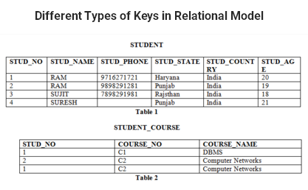

**Candidate Key:** The minimal set of attribute which can uniquely identify a tuple is known as candidate key. For Example, STUD_NO in STUDENT relation.

* The value of Candidate Key is unique and non-null for every tuple.
* There can be more than one candidate key in a relation. For Example, STUD_NO as well as STUD_PHONE both are candidate keys for relation STUDENT.
* The candidate key can be simple (having only one attribute) or composite as well. For Example, {STUD_NO, COURSE_NO} is a composite candidate key for relation STUDENT_COURSE.

**Super Key:**The set of attributes which can uniquely identify a tuple is known as Super Key. For Example, STUD_NO, (STUD_NO, STUD_NAME) etc.

* Adding zero or more attributes to candidate key generates super key.
* A candidate key is a super key but vice versa is not true.

**Primary Key:** There can be more than one candidate key in a relation out of which one can be chosen as primary key. For Example, STUD_NO as well as STUD_PHONE both are candidate keys for relation STUDENT but STUD_NO can be chosen as primary key (only one out of many candidate keys).

**Definition of Strong Entity**

The **Strong Entity** is the one whose existence does not depend on the existence of any other entity in a schema. It is denoted by a **single** **rectangle**. A strong entity always has the **primary** **key** in the set of attributes that describes the strong entity. It indicates that each entity in a strong entity set can be uniquely identified.

Set of similar types of strong entities together forms the **Strong Entity Set**. A strong entity holds the relationship with the weak entity via an **Identifying Relationship**, which is denoted by double diamond in the ER diagram. On the other hands, the relationship between two strong entities is denoted by a single diamond and it is simply called as a **relationship**.

Let us understand this concept with the help of an example; a customer borrows a loan. Here we have two entities first a customer entity, and second a loan entity.

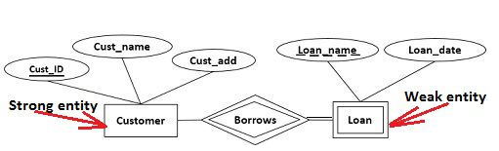

The second thing you can observe that the Customer entity has as primary key Cust_ID which uniquely identify each entity in Customer Entity set.  This makes Customer entity a strong entity on which a loan entity depends.

**Definition of Weak Entity**

A **Weak entity** is the one that depends on its owner entity i.e. a strong entity for its existence. A weak entity is denoted by the **double rectangle**. Weak entity do **not**have the **primary key** instead it has a **partial key** that uniquely discriminates the weak entities. The **primary key of a weak entity** is a composite key formed from the **primary key of the strong entity** and **partial key of the weak entity**.

The collection of similar weak entities is called **Weak Entity Set**. The relationship between a weak entity and a strong entity is always denoted with an **Identifying Relationship** i.e. **double diamond**.

**Differences Between Strong Entity and Weak Entity**

1. The basic difference between strong entity and a weak entity is that the strong entity has a **primary key** whereas, a weak entity has the **partial key** which acts as a discriminator between the entities of a weak entity set.
2. A weak entity always **depends** on the strong entity for its existence whereas, a strong entity is**independent** of any other entity’s existence.
3. A strong entity is denoted with a **single rectangle** and a weak entity is denoted with a **double rectangle**.
4. The relationship between two strong entities is denoted with **single diamond** whereas, a relationship between a weak and a strong entity is denoted with double diamond called **Identifying Relationship**.
5. The strong entity may or may not show the total participation in its relations, but the weak entity always shows **total participation** in the identifying relationship which is denoted by the double line.